**Tutorial Mininet 3 by Randi Ekklesia Ginting (161402108)**

**Access via SSH**

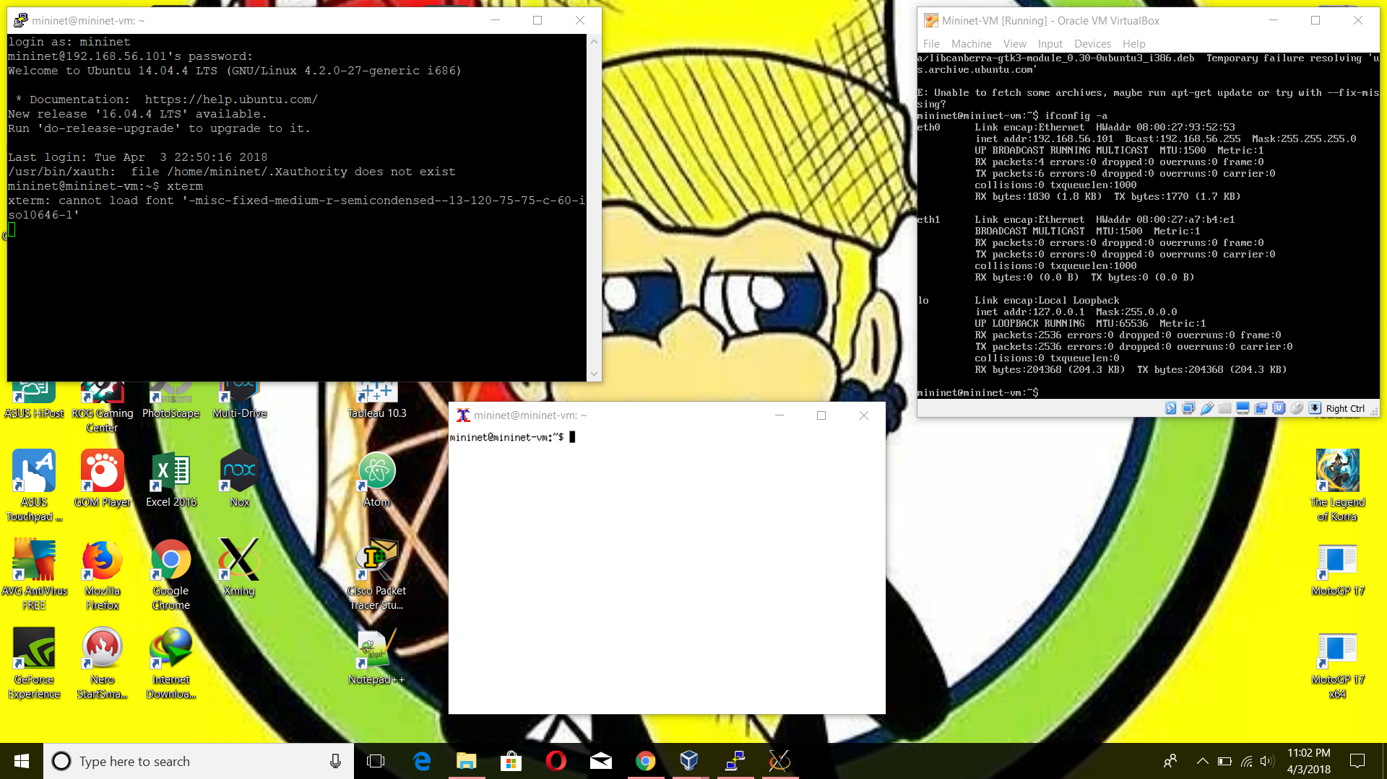

# Tes

# C:\Users\ASUS\Pictures\Screenshots\Screenshot (45).png

Tes – Wireshark

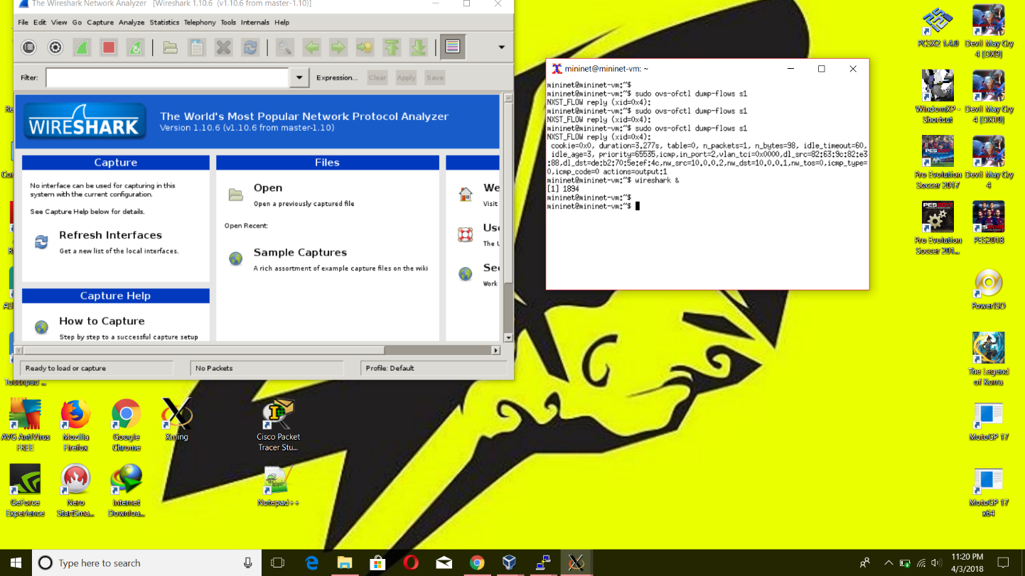

# Check

mininet@mininet-vm:~$ sudo apt-get update

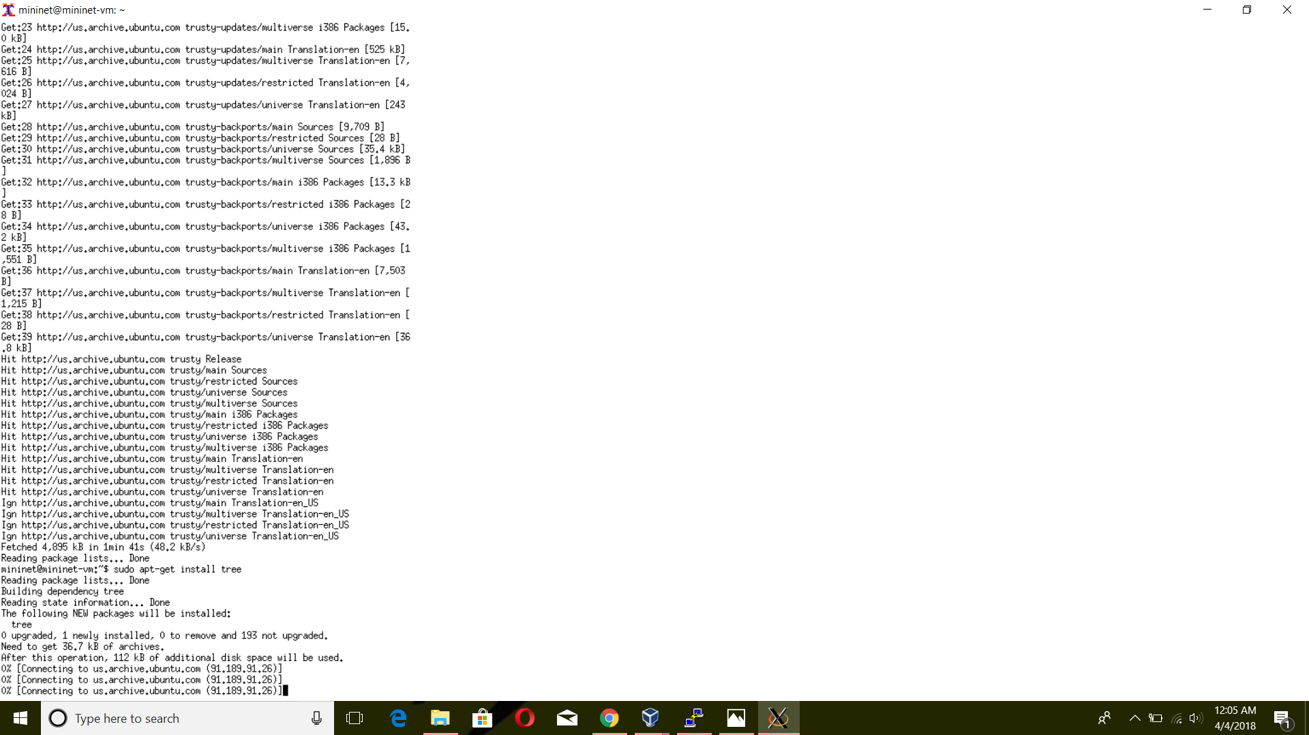mininet@mininet-vm:~$ sudo apt-get install tree

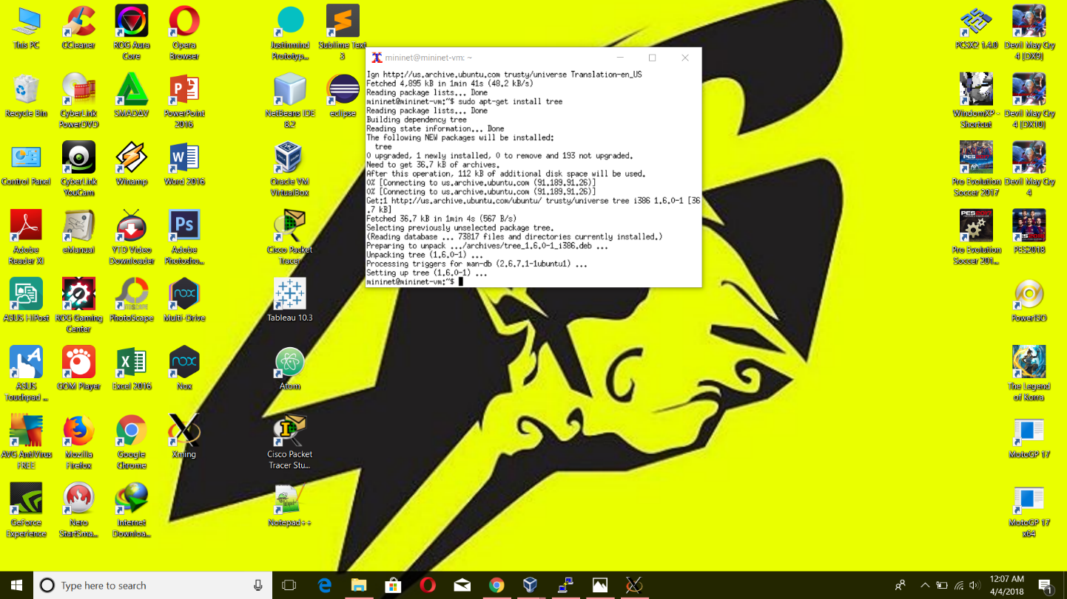

mininet@mininet-vm:~$ tree –L 1

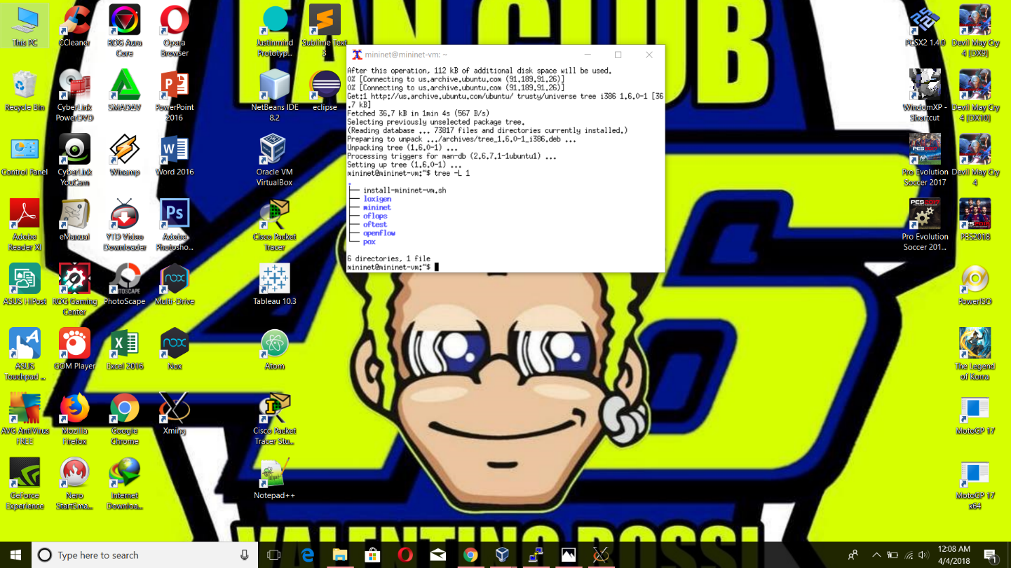

mininet@mininet-vm:~/mininet$ tree –L 2 –d

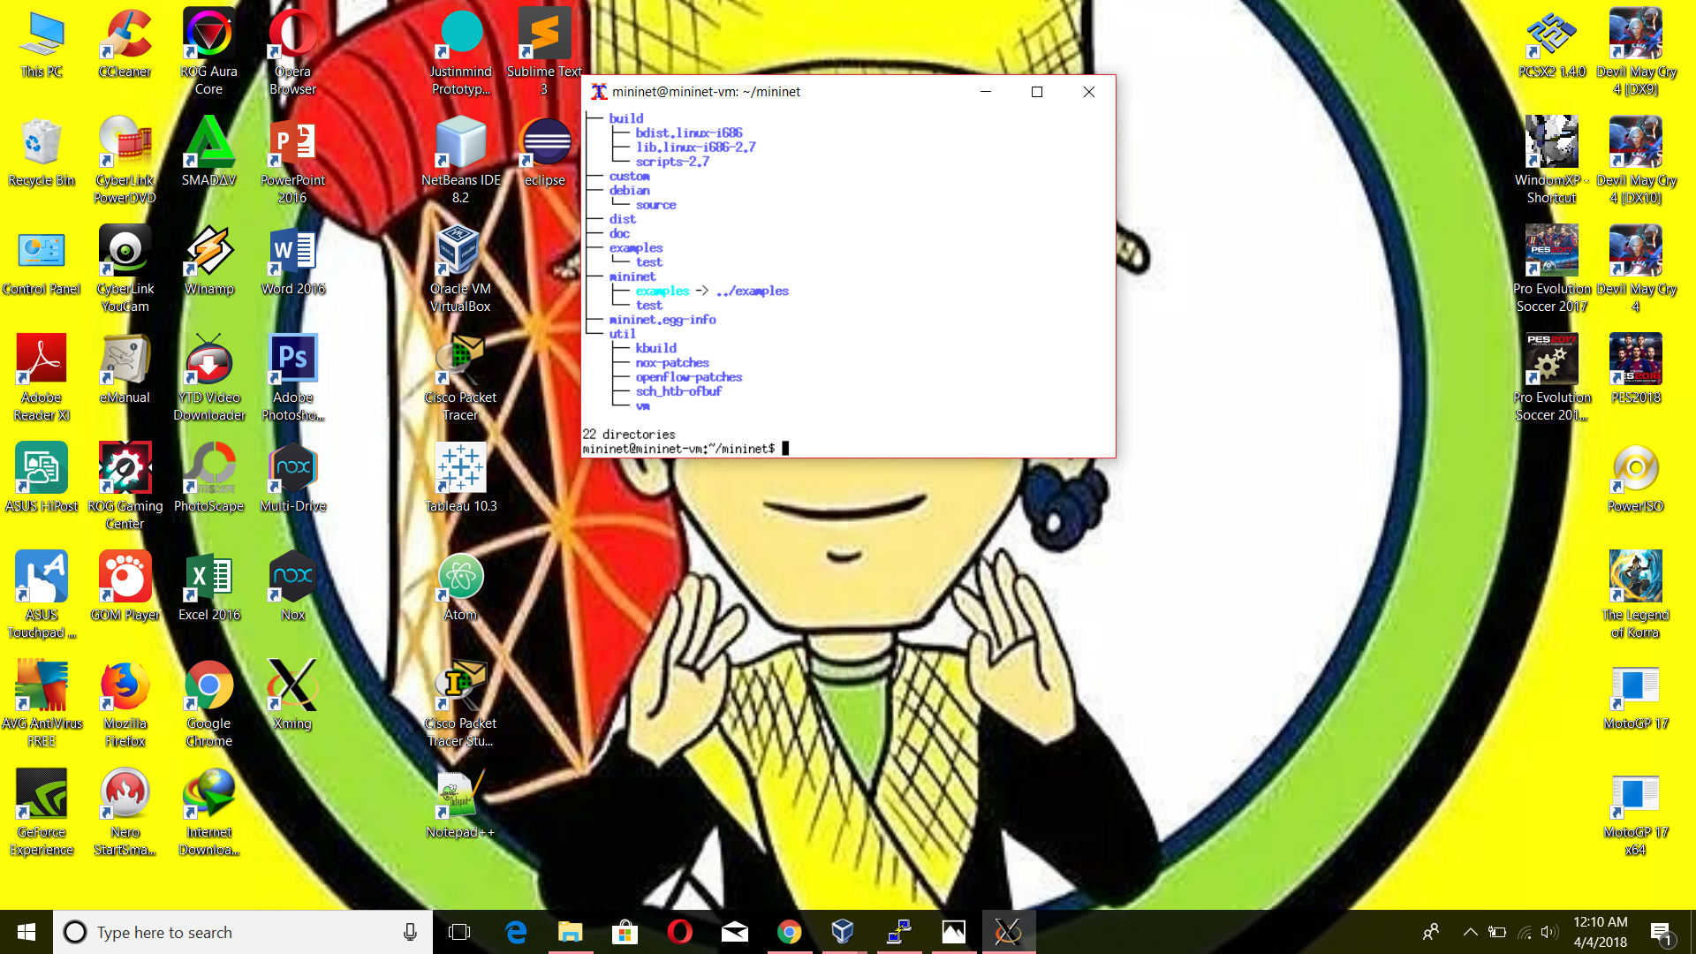

mininet@mininet-vm:~/mininet/examples$ ll

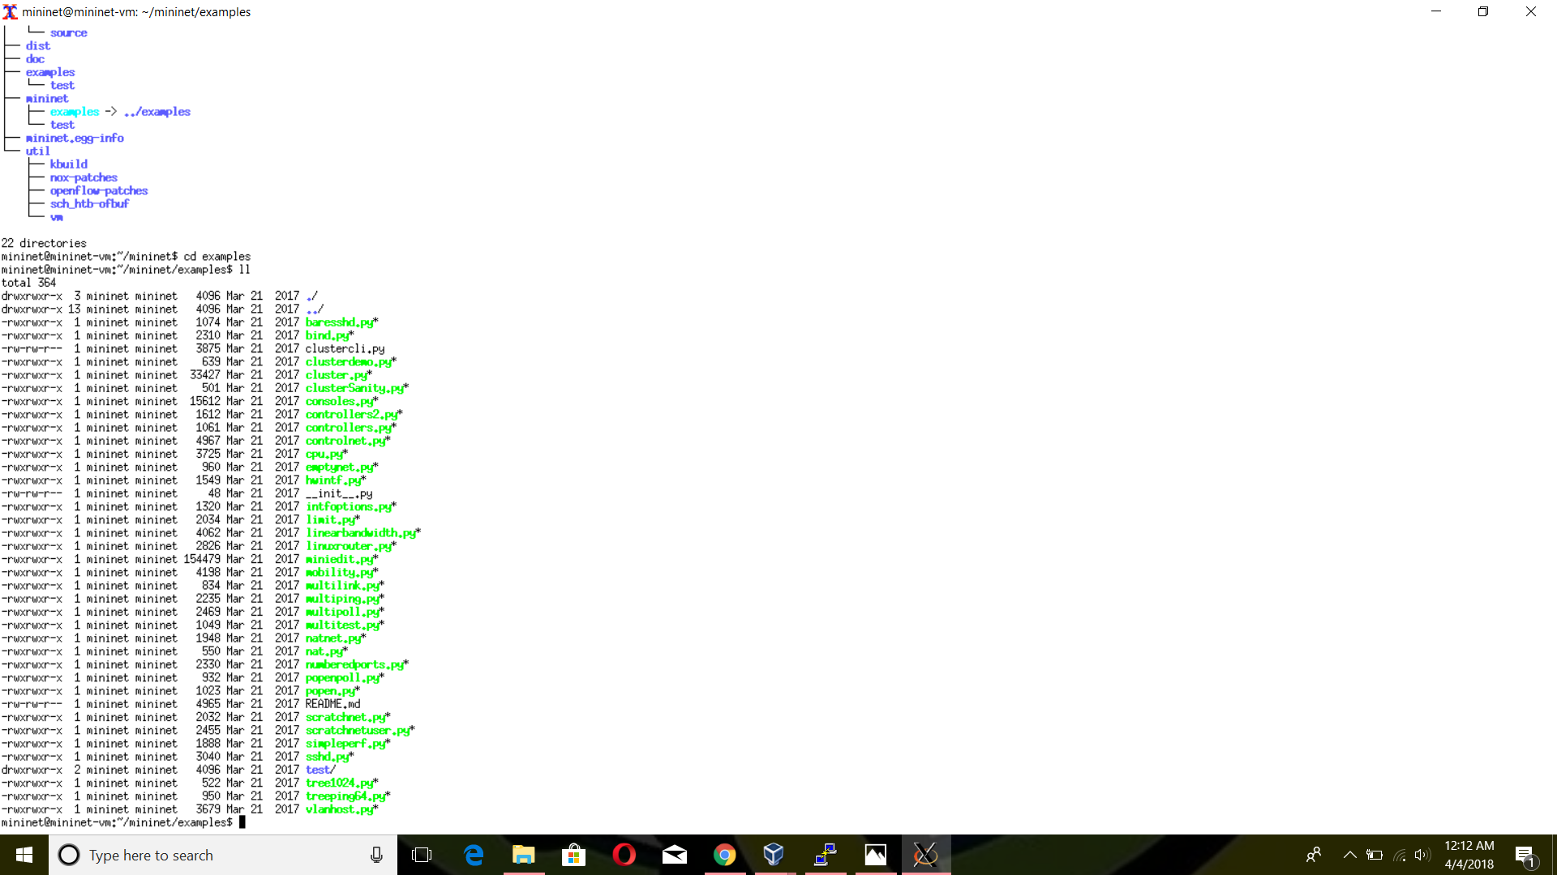

# Notes Mininet Walkthrough

$ sudo mn [--topo=minimal]

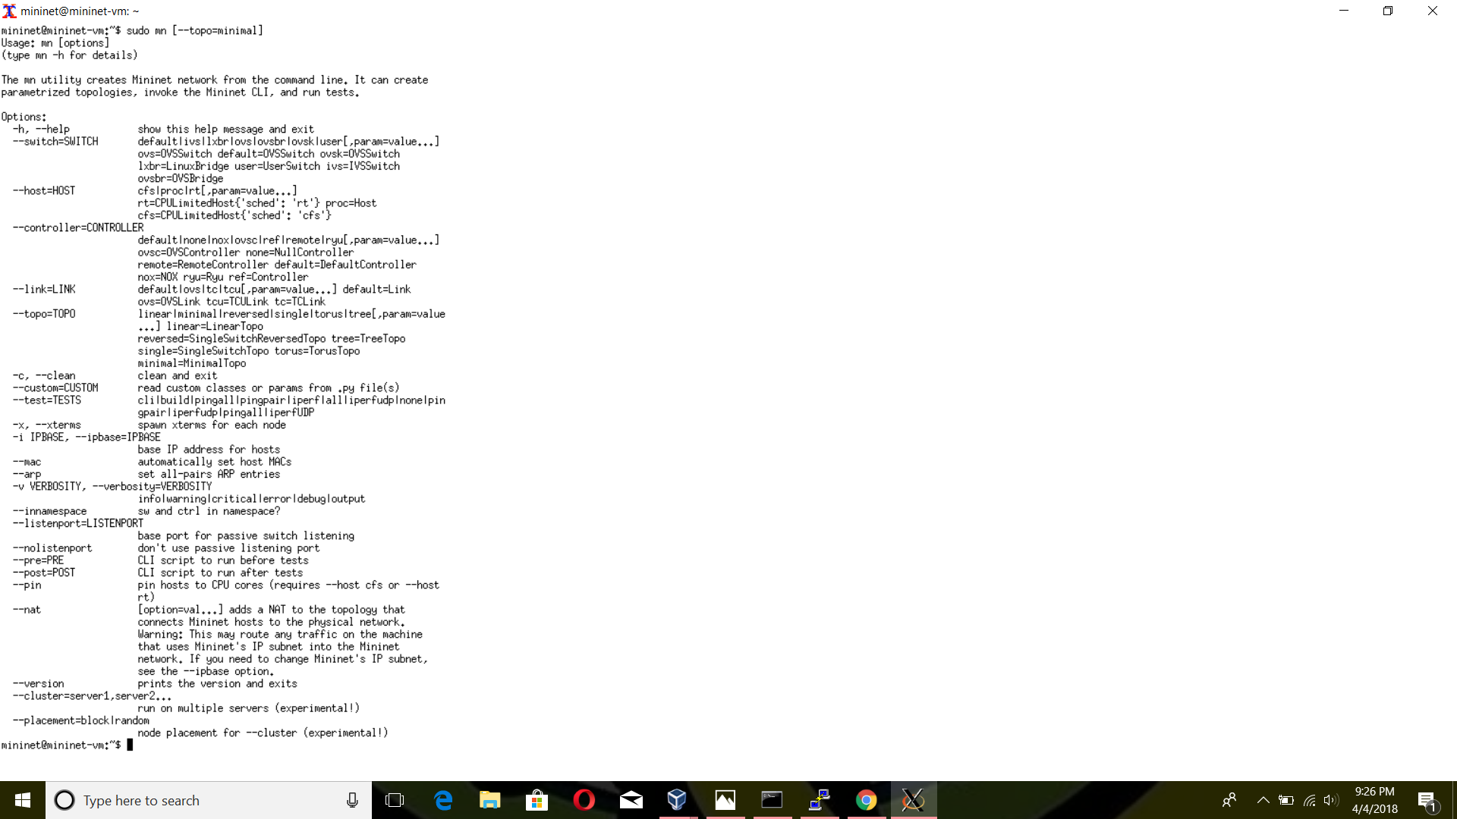

$ sudo mn --test pingpair

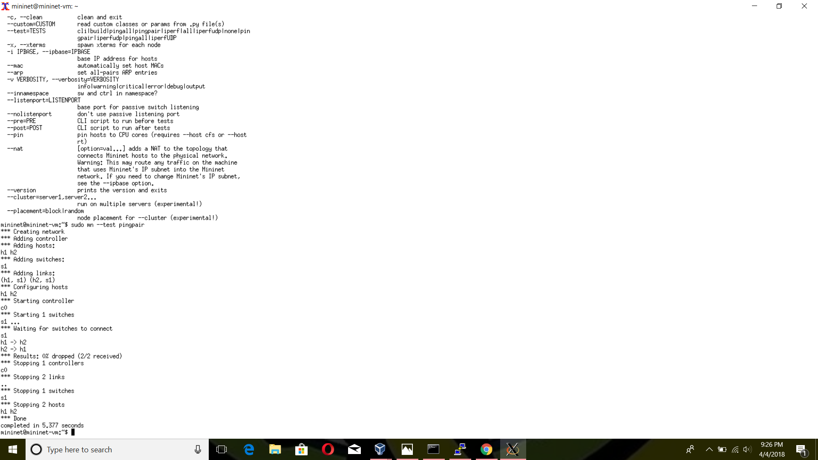

$ sudo mn --test iperf

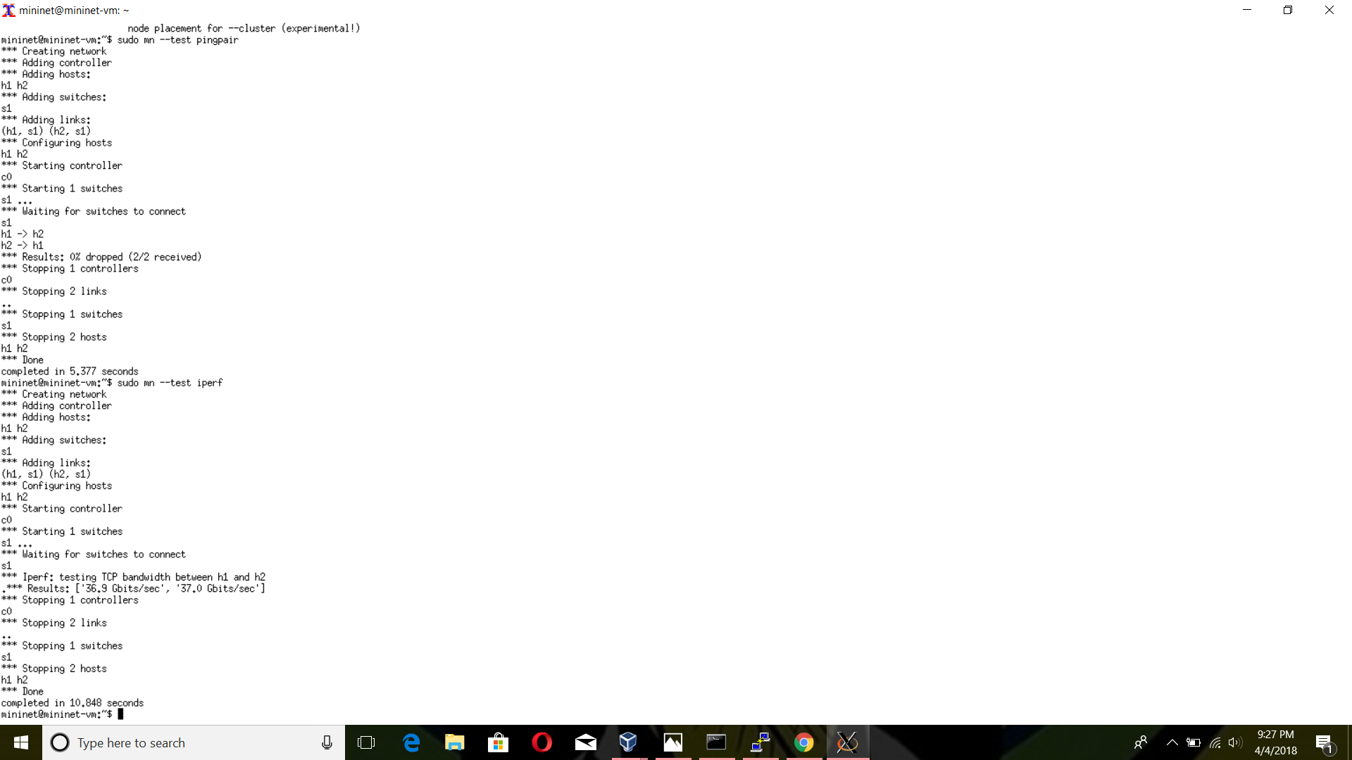

$ sudo mn --link tc,bw=10,delay=10ms

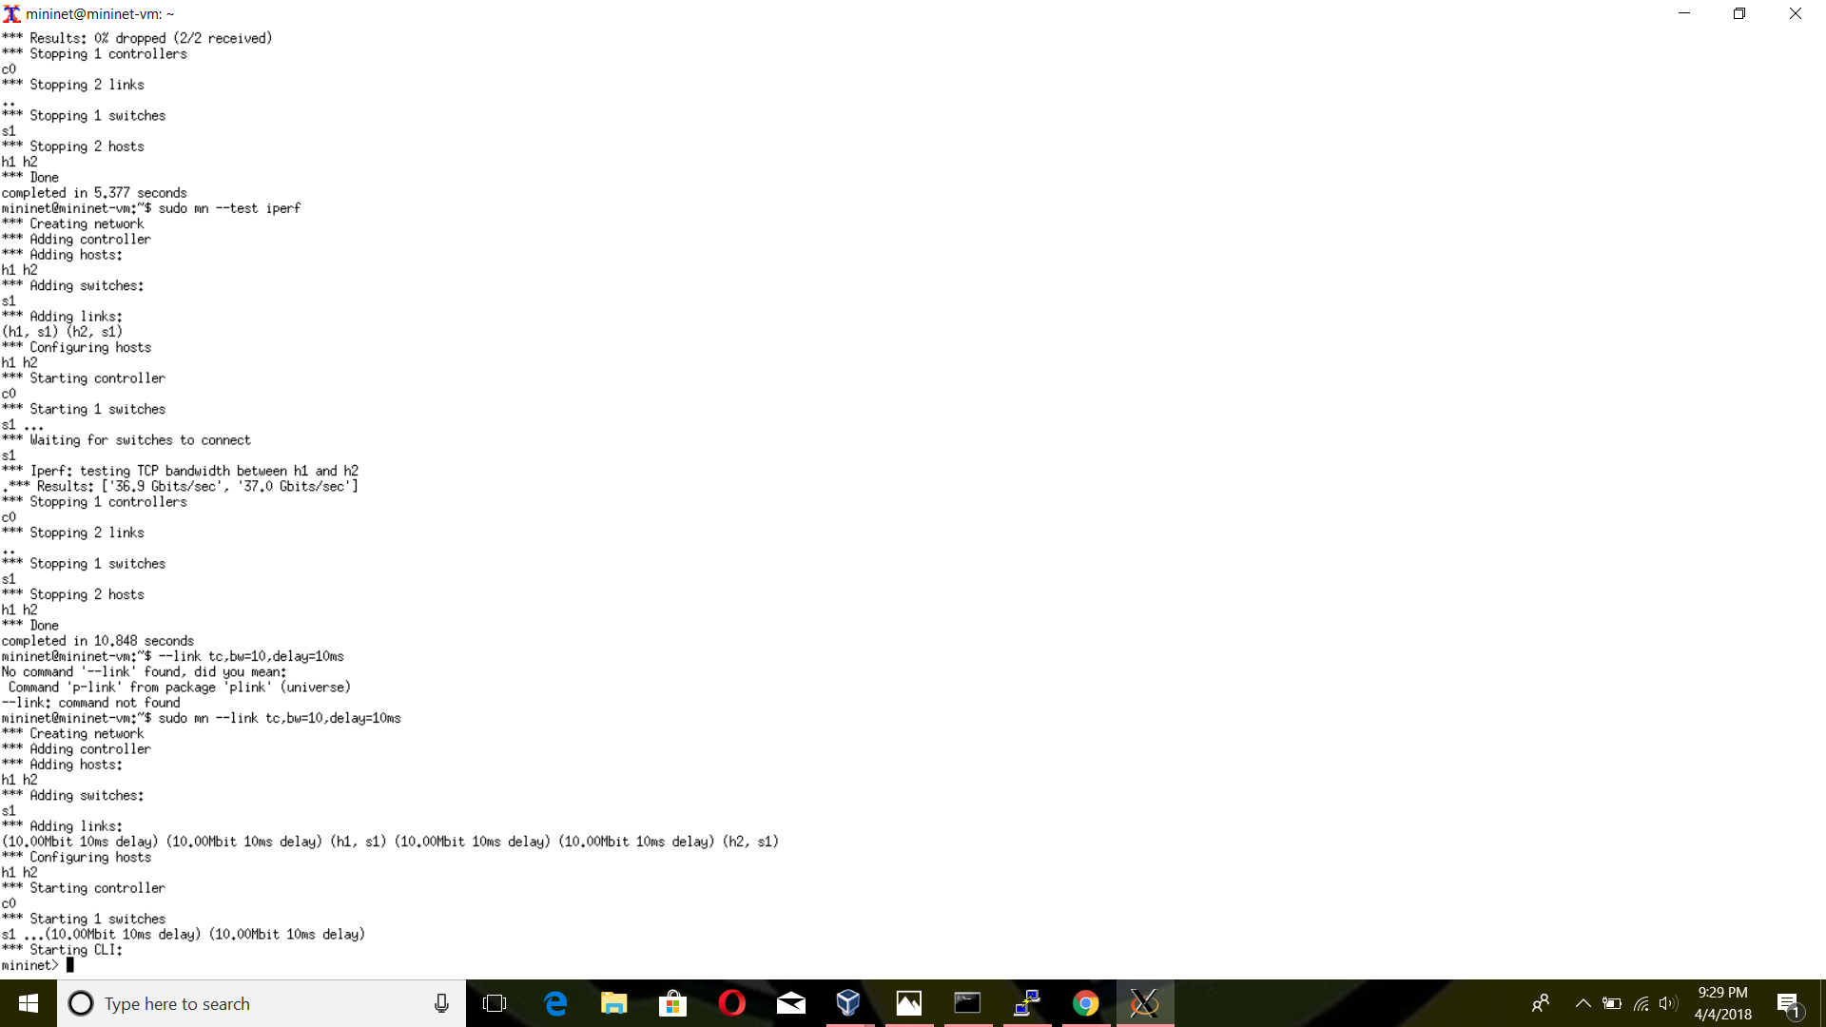

$ sudo mn –test pingall –topo single,3

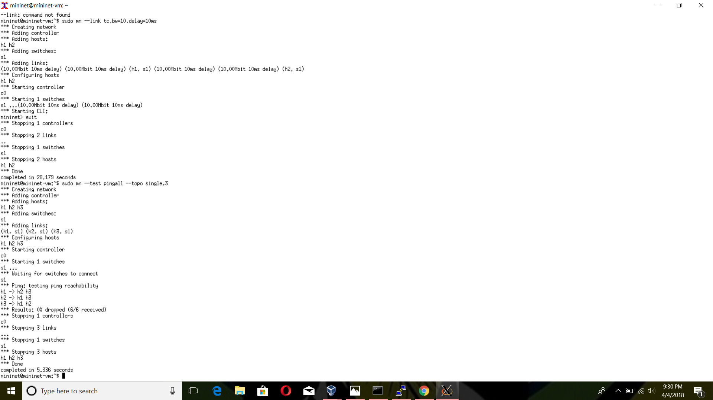

$ sudo mn --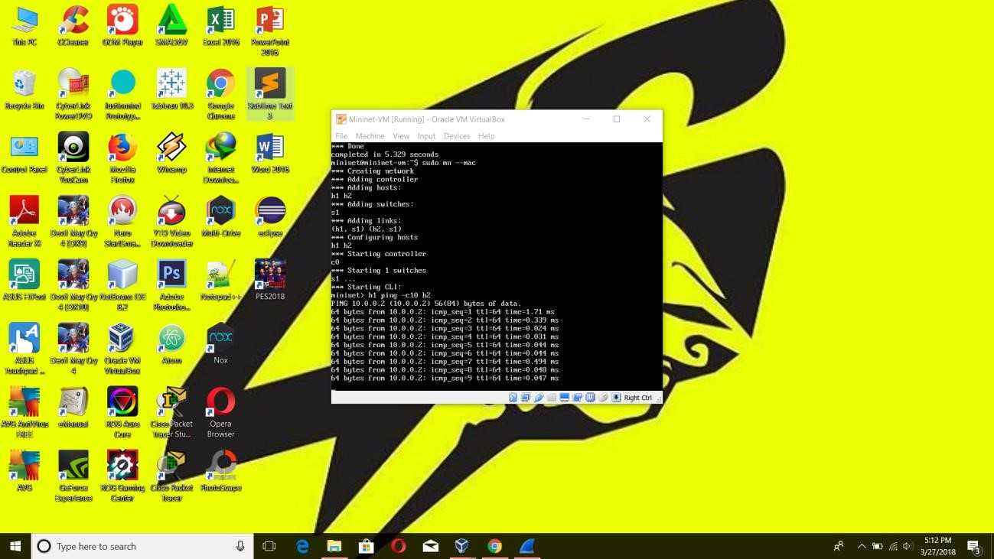test pingall –topo mytopo –custom ~/mininet/custom/topo-2sw-2host.py

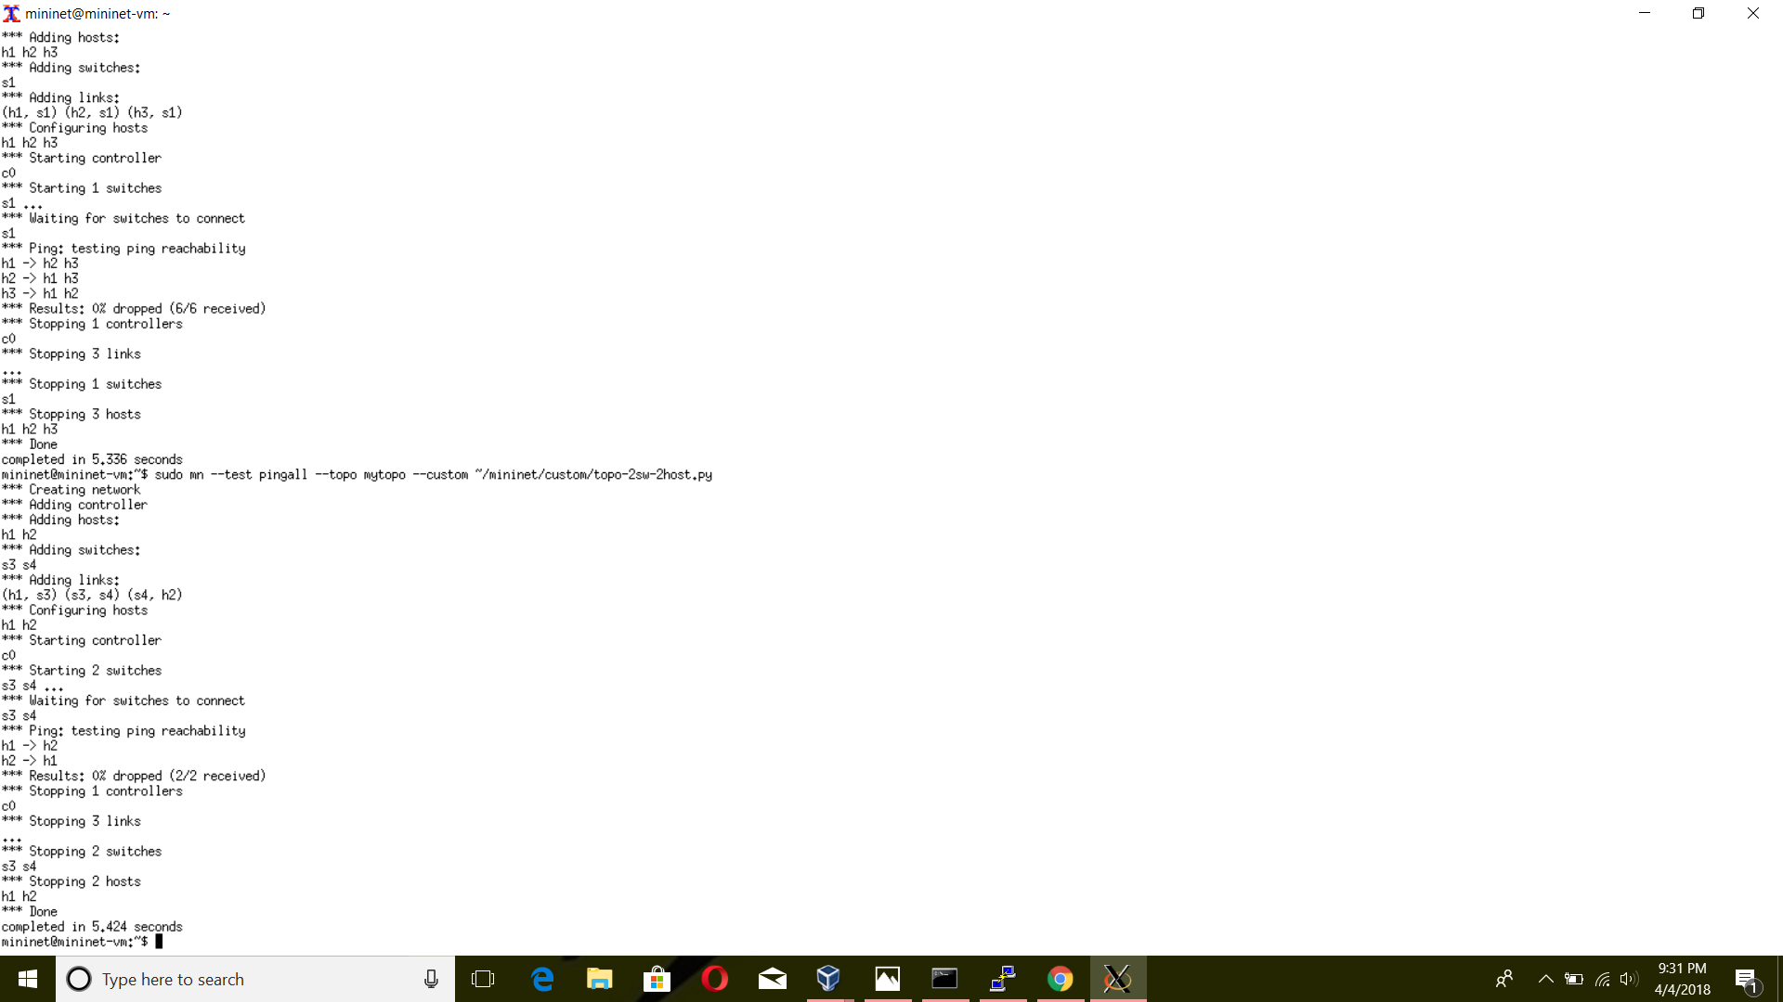

$ sudo mn –mac

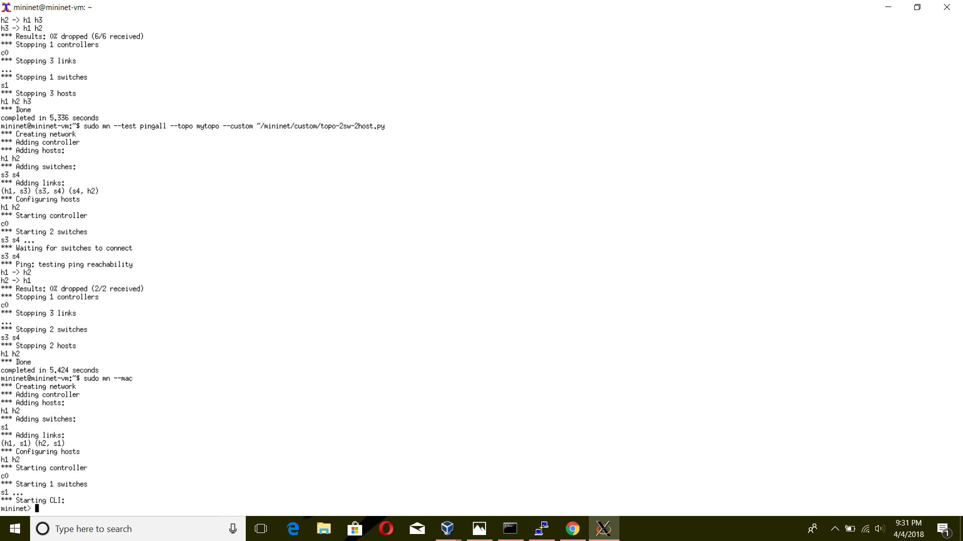

Mininet> h1 ping –c10 h2

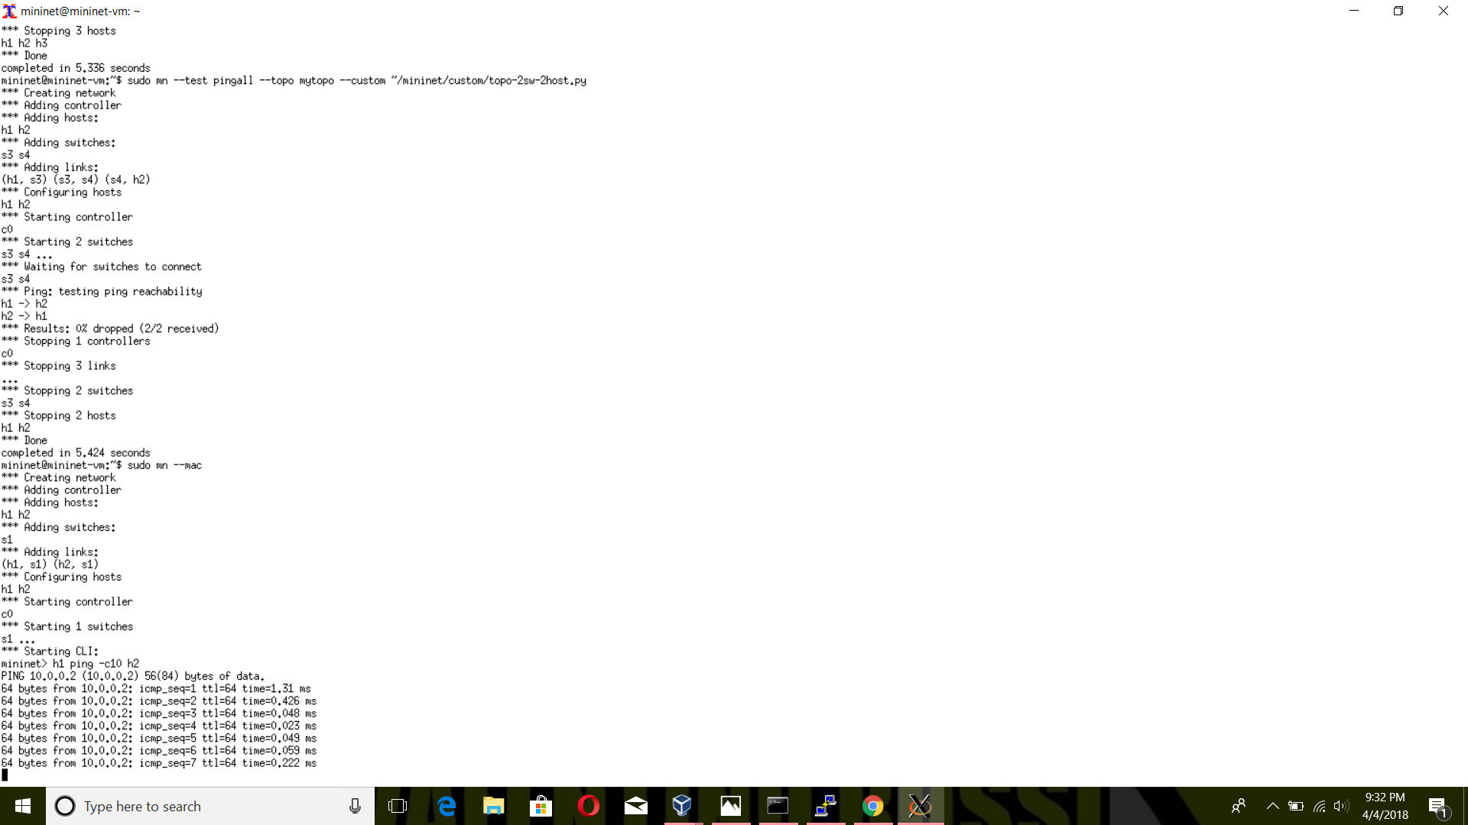

Mininet> pingall

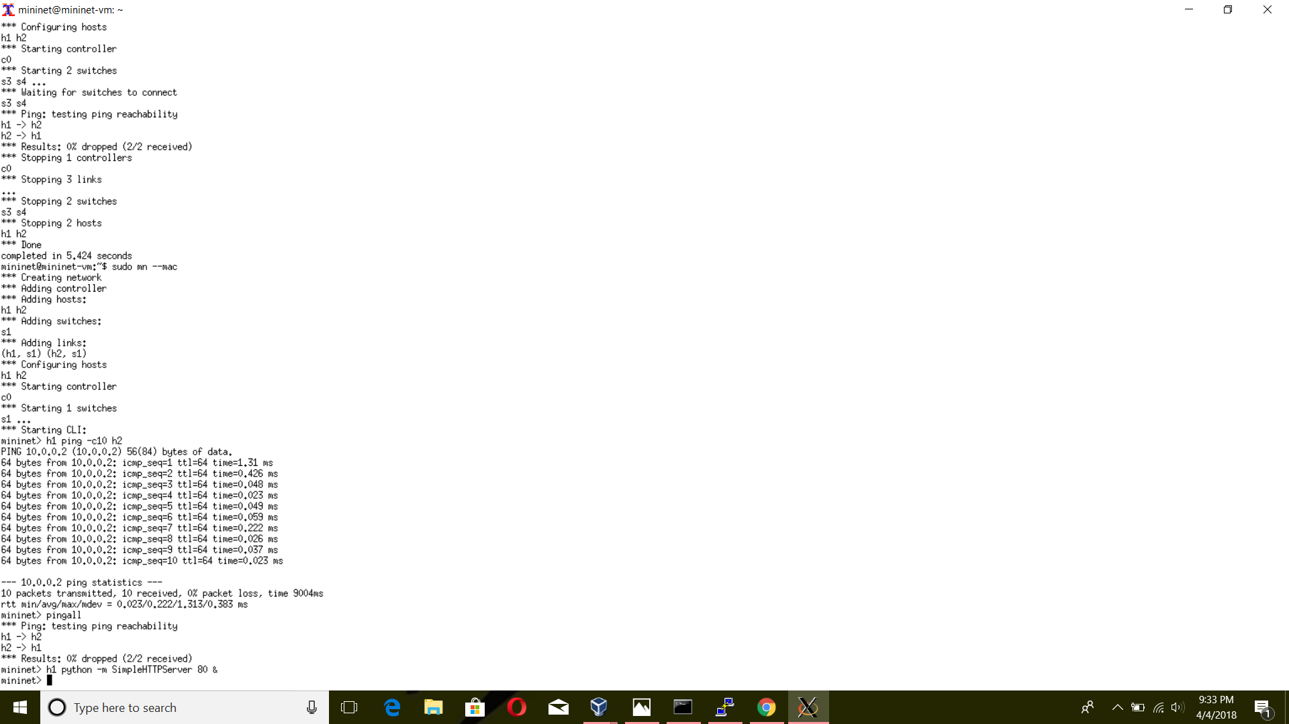

Mininet> h1 python –m SimpleHTTPServer 80 &

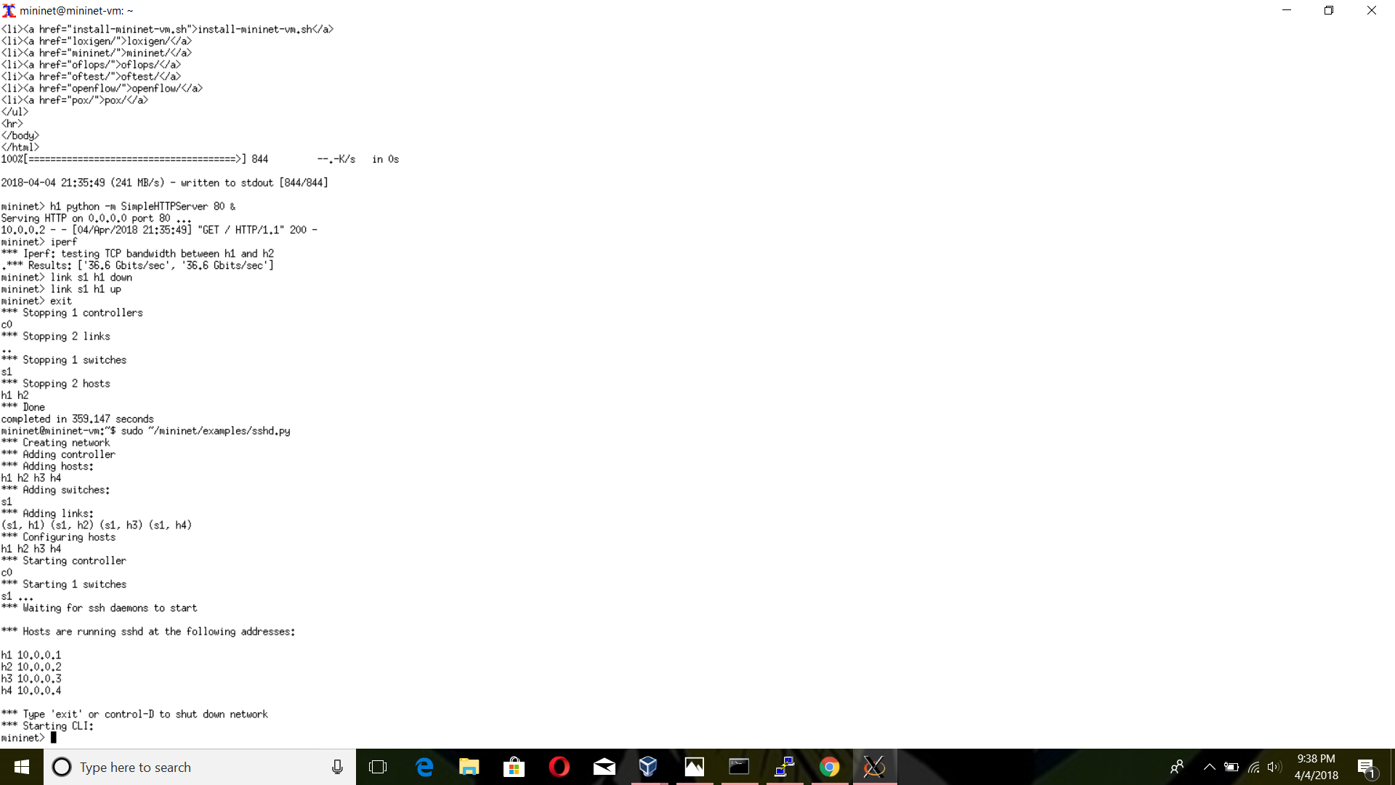

Mininet> h2 wget -0 - h1

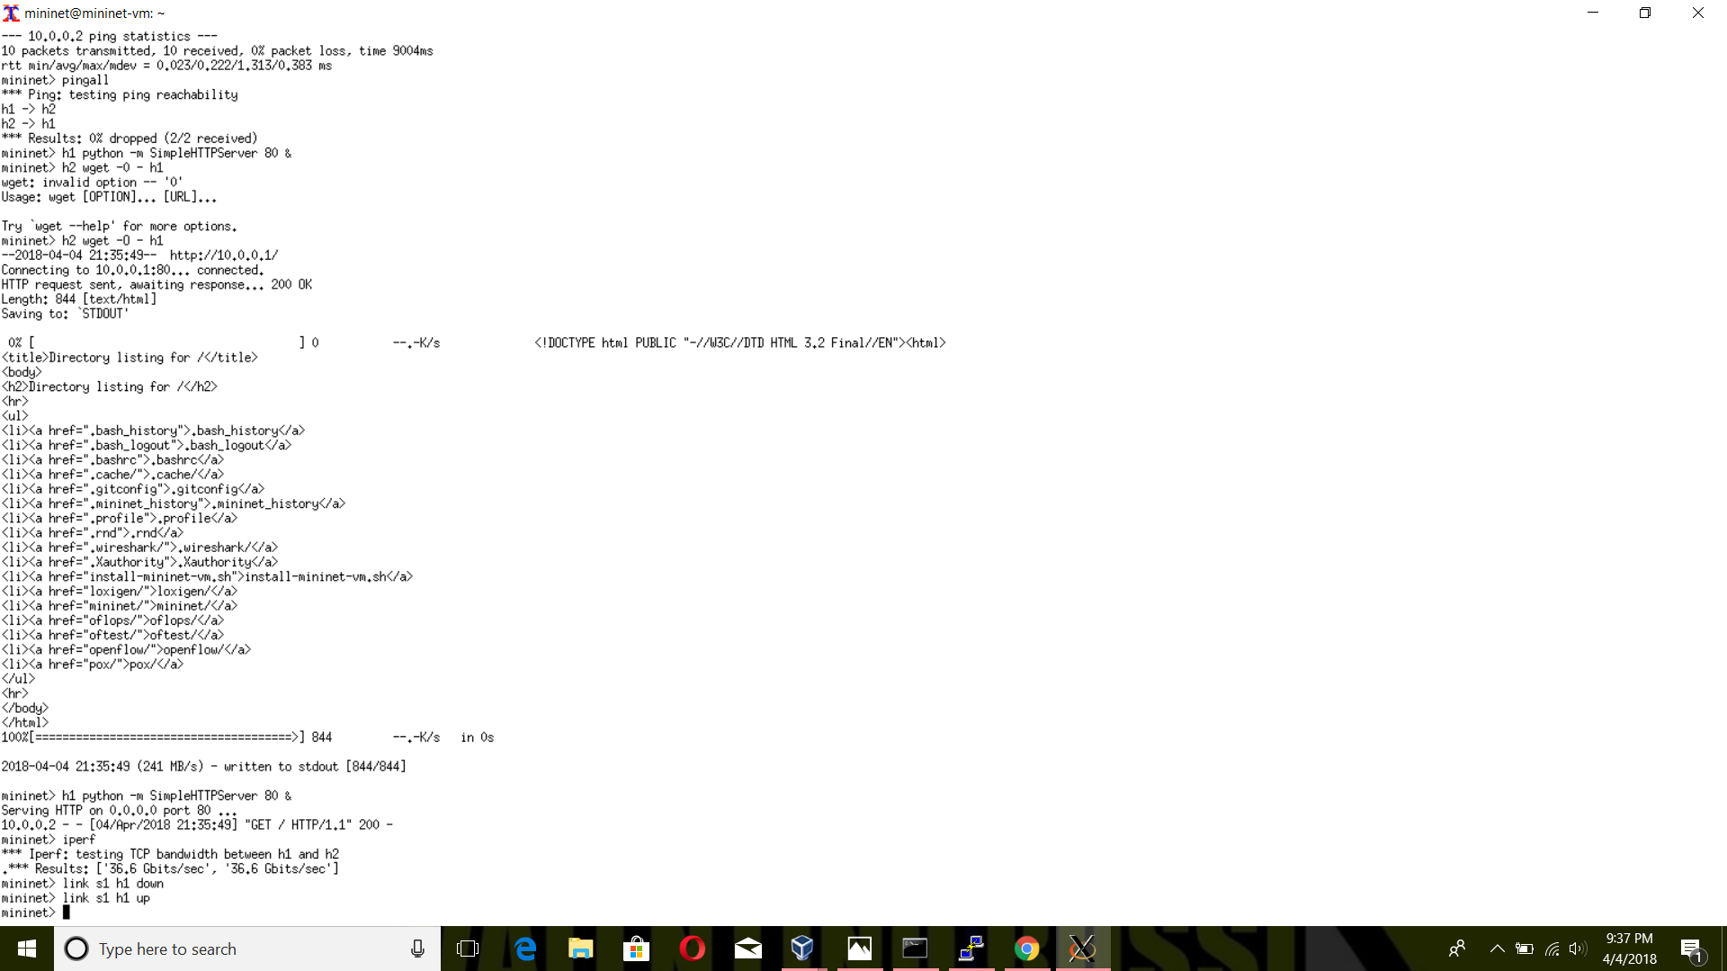

Mininet> iperf



Mininet> link s1 h1 down



Mininet> link s1 h1 up



$ sudo ~/mininet/examples/sshd.py



**Notes Mininet Sample Workflow**

# # Creating a Network

$ sudo mn –switch ovs –controller ref –topo tree,depth=2,fanout=8 –test pingall

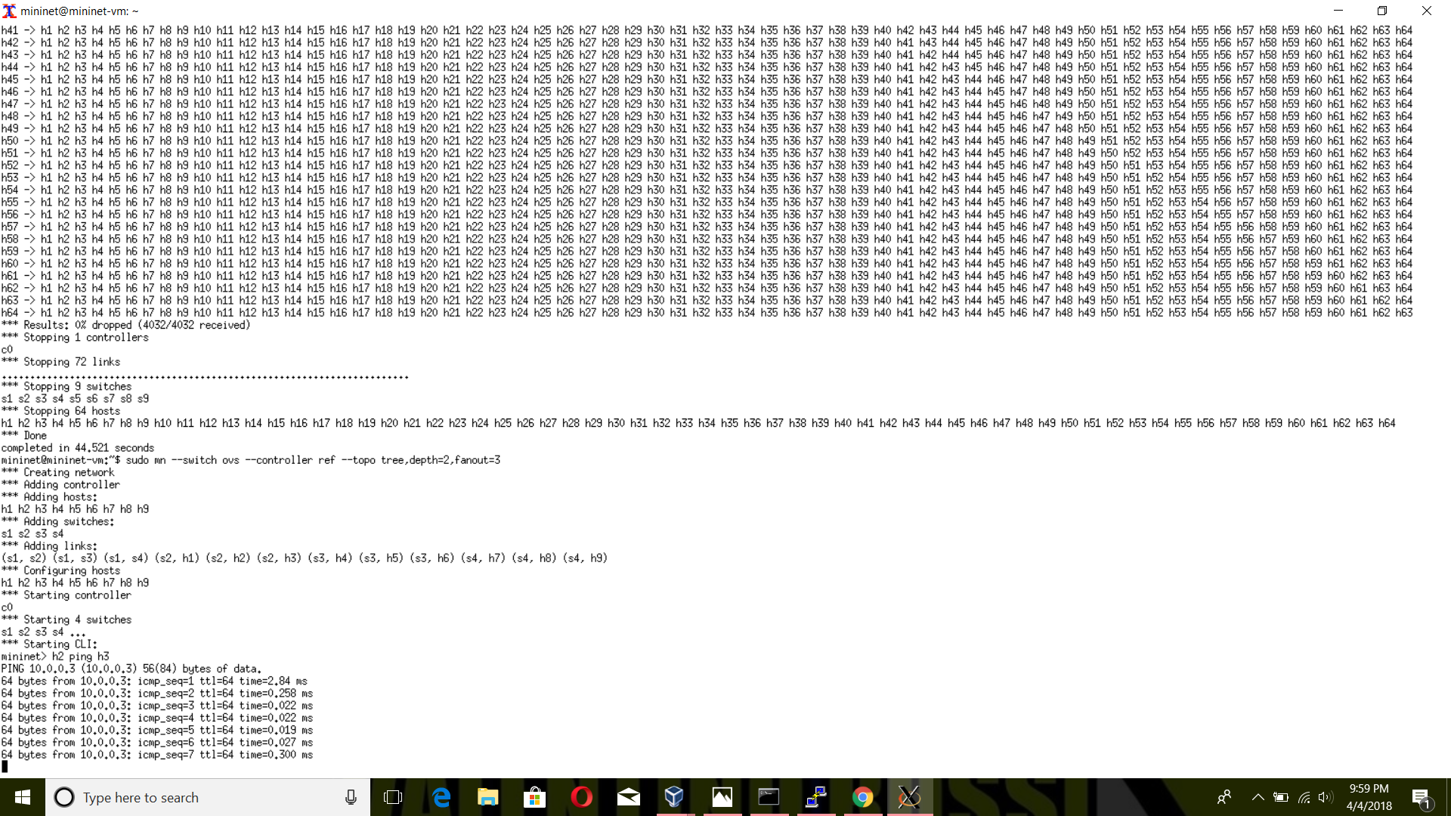

# Interacting with a Network

Mininet> h2 ping h3



Mininet> h2 python –m SimpleHTTPServer 80 >& /tmp/http.log &

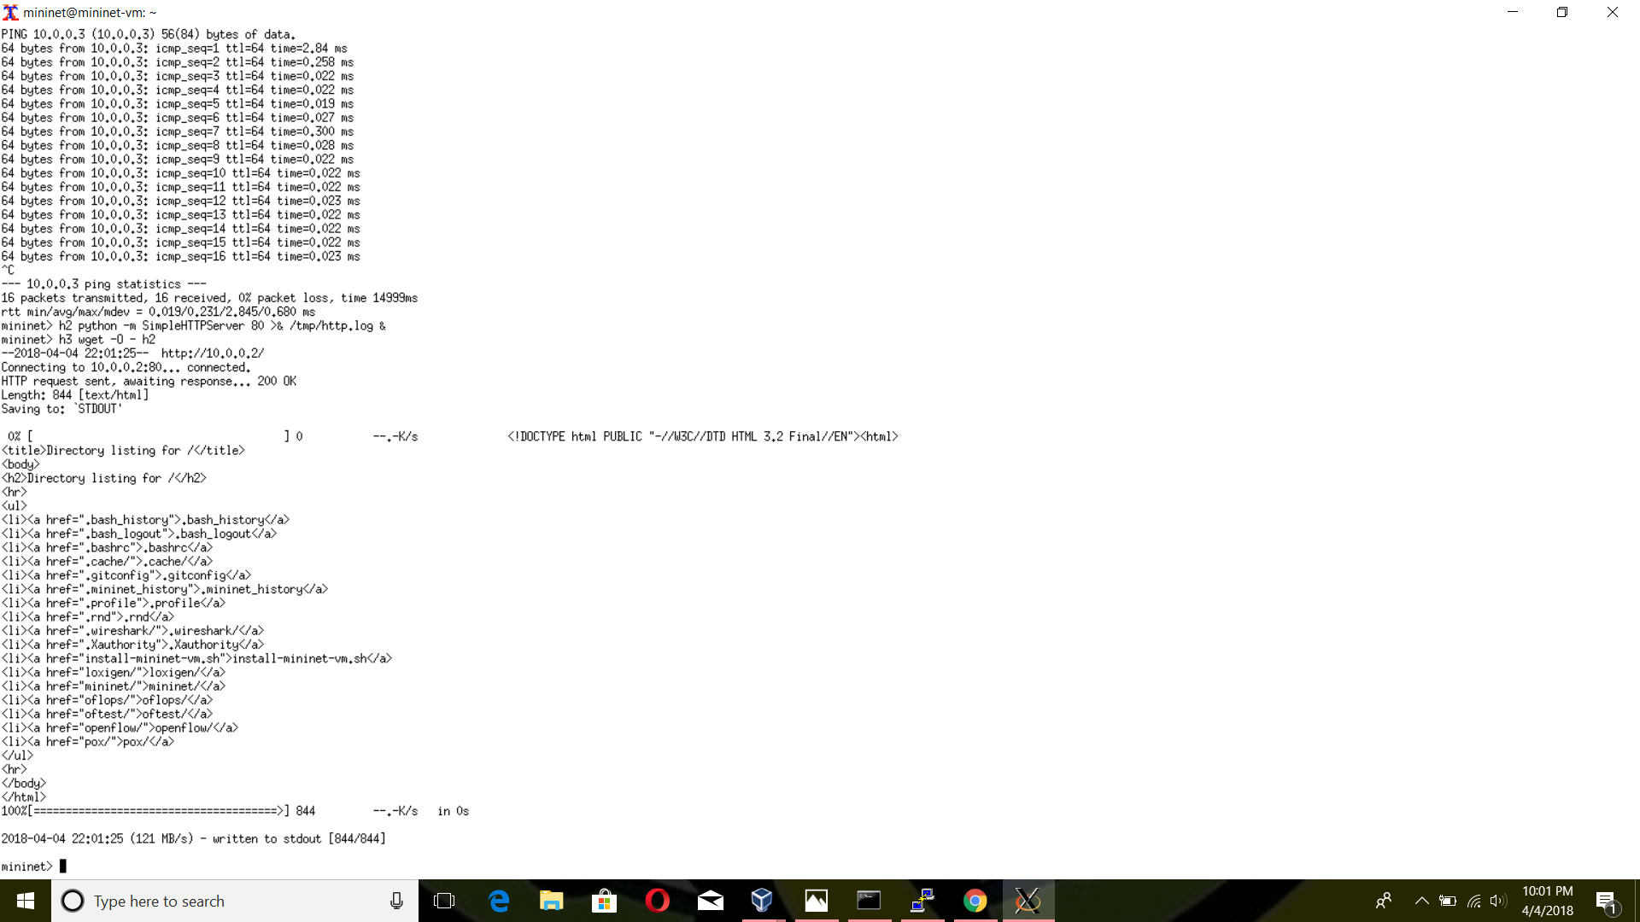

Mininet> h3 wget -0 – h2

